TASK MANAGEMENT SYSTEM
@CREATIVITY THINK (9483175986/7019689991)

ABSTRACT:
The Task Management System is a web-based platform developed to facilitate team collaboration, task assignment, progress tracking, notifications, and calendar integration. It allows users to create, assign, and update tasks while monitoring deadlines and task completion. Administrators have access to dashboards for reviewing team performance, configuring notification rules, managing users, and analyzing task metrics. Built with Django and Django REST Framework for backend operations and React with Redux for frontend interactions, the system ensures a streamlined workflow, efficient task management, and improved team productivity..

INTRODUCTION OF THE PROJECT:
Efficient task management is a critical component of modern organizational operations. Many teams rely on scattered tools, emails, or spreadsheets, leading to missed deadlines, miscommunication, and lack of accountability. The Task Management System addresses these challenges by providing a centralized, digital environment for task assignment, status tracking, notifications, and analytics. The system enhances collaboration among team members, ensures timely updates, integrates seamlessly with calendars, and provides administrators with oversight and analytical insights for better decision-making..

PROJECT OBJECTIVES:

• Provide a centralized platform for task creation, assignment, and tracking
• Enable real-time task status updates and progress monitoring
• Integrate tasks with calendar views for planning and scheduling
• Send notifications for new tasks, updates, and approaching deadlines
• Offer dashboards for team-level and individual task analytics
• Allow administrators to manage users, teams, and notification rules
• Ensure secure authentication and role-based access control
• Support scalability for small and large teams

PROBLEM OF THE STATEMENT:
Traditional methods of task management, such as email, spreadsheets, or chat applications, are inefficient and prone to errors. Teams often face difficulty in monitoring task completion, meeting deadlines, or managing notifications. Administrators lack real-time insights into team progress, and collaboration becomes fragmented. The Task Management System provides a structured and centralized solution with real-time updates, calendar integration, automated notifications, and dashboards, ensuring improved efficiency, accountability, and streamlined team workflows..

MOTIVATION OF THE PROJECT:
• To improve team collaboration and productivity
• To provide a centralized platform for task tracking
• To ensure tasks are completed on time with automated notifications
• To enable administrators to monitor and manage teams effectively
• To reduce dependence on multiple unstructured tools
• To create a scalable and adaptable solution for diverse project scenarios
• To offer analytics-driven insights for better decision-making

BLOCK DAIGRAM OF PROJECT:

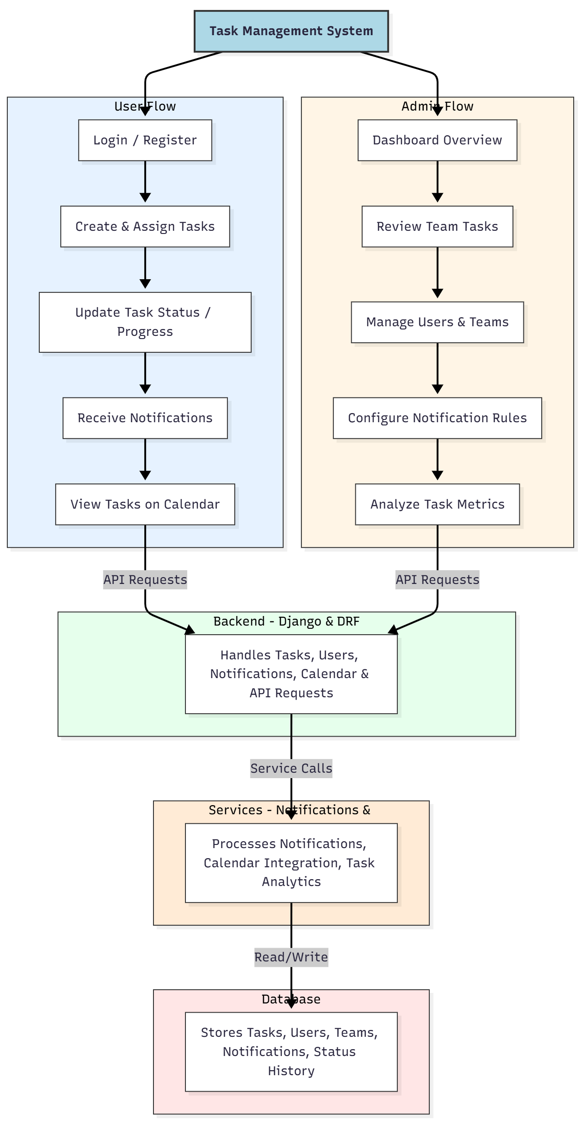

WORKING OF THE PROJECT:
The system starts with users logging in and creating tasks, which can then be assigned to team members with deadlines and priorities. Users update task status, and automated notifications are sent for new assignments, updates, or impending deadlines. Calendar integration allows visual planning of tasks. Administrators monitor team performance through dashboards, manage users and teams, configure notifications, and analyze task metrics. All operations are processed via Django REST APIs and stored in a relational database, ensuring reliable, secure, and scalable task management..

SOFTWARE REQUIREMENT:
- Backend:
  - Python 3.x
  - Django
  - Django REST Framework
  - SQLite/PostgreSQL
- Frontend:
  - Node.js and npm
  - React.js
  - Axios
- Development Tools:
  - Visual Studio Code
  - Postman (for testing APIs)
  - Git/GitHub (for version control)
- Server/Deployment (Optional):
  - Gunicorn, Nginx, or Heroku/AWS for hosting

ADVANTAGES OF THE PROJECT:

• Centralized task management and progress tracking
• Real-time updates and automated notifications
• Calendar integration for planning and scheduling
• Admin dashboard for monitoring, user management, and analytics
• Reduces miscommunication and missed deadlines
• Scalable for small and large teams
• Enhances accountability and team productivity
• Secure and reliable API-based platform

APPLICATIONS OF THE PROJECT:
• Corporate offices and business teams
• IT and software development projects
• Educational institutions for project coordination
• Freelance and remote teams
• Research and academic team collaborations
• SMEs requiring structured task tracking

REFERENCES:

- Django REST Framework Documentation — Django Software Foundation. Django Documentation. Available: https://docs.djangoproject.com/
- Django REST Framework. DRF Documentation. Available: https://www.django-rest-framework.org/
- React. React Official Documentation. Available: https://reactjs.org/docs/getting-started.html
- Redux. Redux Documentation. Available: https://redux.js.org/introduction/getting-started
- PostgreSQL Global Development Group. PostgreSQL Documentation. Available: https://www.postgresql.org/docs/
- MySQL. MySQL Reference Manual. Available: https://dev.mysql.com/doc/
- Git. Git Documentation. Available: https://git-scm.com/doc
- Node.js. Node.js Documentation. Available: https://nodejs.org/en/docs/
- Axios. Axios Documentation. Available: https://axios-http.com/docs/intro
- Socket.io Documentation – https://socket.io/docs/

